Raman / SERS Study on N-Acetylmuramic Acid (NAM)
1. Objective of the Completed Work
The completed work focused on evaluating the Raman response of N-acetylmuramic acid (NAM) and systematically examining how instrumental parameters influence the recorded signal.
The scope of completed work includes:
- Acquisition of Raman spectra of NAM under controlled experimental conditions
- Exploration of laser power and integration time dependence
- Theoretical Raman simulation for reference comparison

2. Sample and Reference Information
- Sample: N-Acetylmuramic acid (NAM)
- Form tested:
  - Dry powder (primary dataset)
  - Aqueous solution (initial attempt)
The molecular structure of NAM was obtained from PubChem (CID 5462244) and corresponds to the analytical-grade standard supplied by Sigma-Aldrich (≥98% purity).

3. Instrumentation and Software Used
- Instrument: Microscope-coupled Raman spectroscopy system
- Acquisition software: BWSpec
Controllable parameters available in the system:
- Integration time (seconds)
- Laser level (%)
- Time averaging (number of scans)

4. Computational Simulation Completed
Density Functional Theory (DFT) calculations were carried out to obtain a theoretical Raman reference for NAM.
- Software: Gaussian 09
- Method: B3LYP
- Basis set: 6-311+G(d,p)
Completed computational steps:
- Geometry optimization of NAM
- Vibrational frequency calculation with Raman activity enabled
- Confirmation of structural stability (no imaginary frequencies)
Initial attempts using ORCA were unsuccessful due to execution issues; therefore, Gaussian 09 was used for all reported simulations.

5. Experimental Data Collection Strategy
A controlled spectroscopy approach was followed in all measurements:
At any given time, only one experimental parameter was varied while all others were kept constant.

6. Raman Measurements Performed
6.1 NAM Powder Measurements
Raman spectra of NAM powder were recorded using systematic parameter variation.
Integration times tested:
- 5 s
- 10 s
- 15 s
- 20 s
- 25 s
For each integration time:
- Time average: 2 (constant)
- Laser power varied from 5% to 80%
- Approximately 16 spectra recorded per integration time
This resulted in a comprehensive dataset covering:
- Laser power dependence at fixed integration time
- Integration time dependence at fixed laser power

6.2 Solution-Phase Measurements
NAM was also tested in aqueous solution during an initial experimental phase.
No distinct Raman peaks were observed in the solution measurements.

7. Summary of Work Completed
The following tasks have been completed:
- ✔ Raman data acquisition of NAM powder across multiple laser powers and integration times
- ✔ Initial Raman measurements of NAM in solution
- ✔ DFT-based Raman simulation of NAM using Gaussian 09

From Laptop:
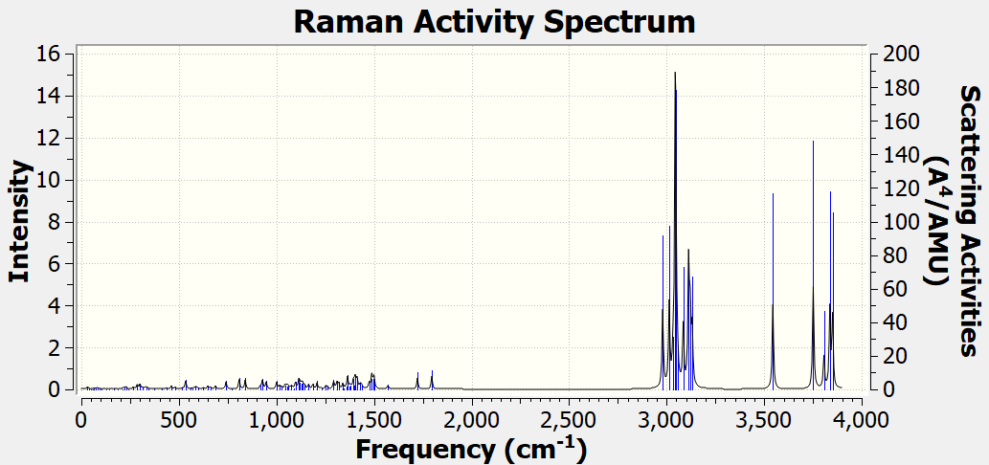

From PC:
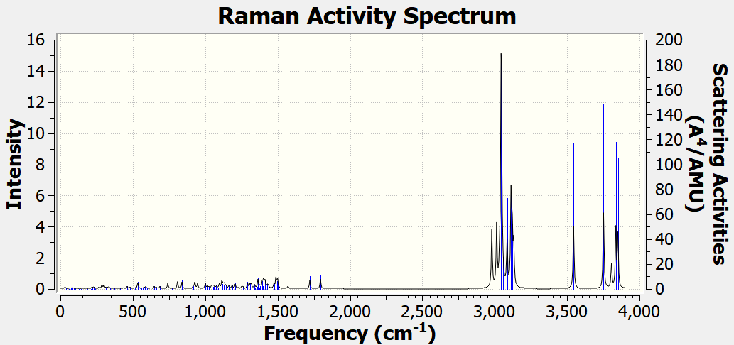

Plotting the data with origin software
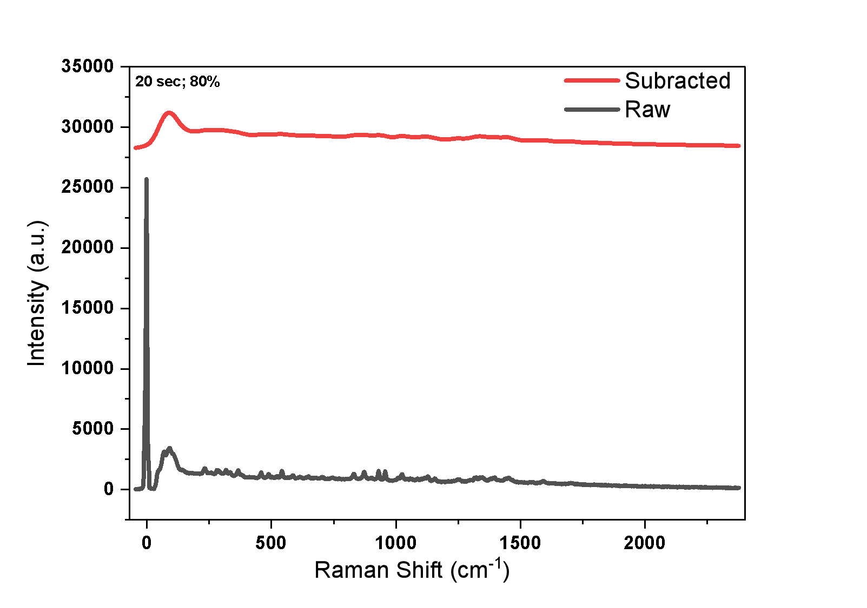
Excel file with Dry powder data
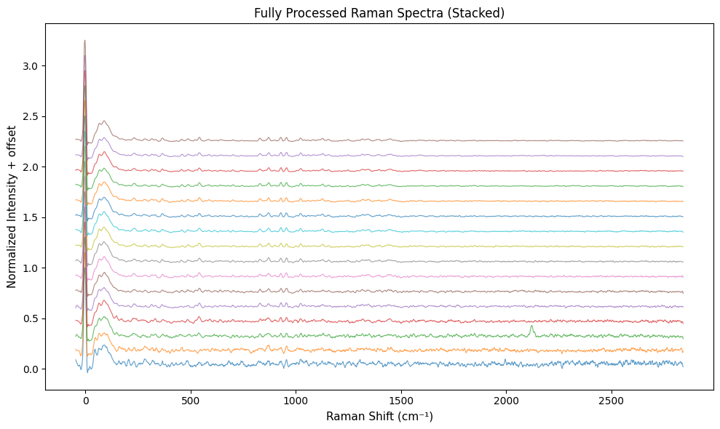

Verification of Chemical Identity: PubChem vs Sigma-Aldrich
To ensure that the experimental material corresponds to the correct molecular entity, the identity of N-acetylmuramic acid (NAM) used in this study was verified by comparing key chemical identifiers between the PubChem reference database and the commercially supplied Sigma-Aldrich standard.
Identity Matching Criteria
Parameter | PubChem Reference | Sigma-Aldrich Standard
Compound name | N-Acetylmuramic acid | N-Acetylmuramic acid
Common abbreviation | NAM / MurNAc | NAM / MurNAc
Molecular formula | C₁₁H₁₉NO₈ | C₁₁H₁₉NO₈
Molecular weight | 293.27 g·mol⁻¹ | 293.27 g·mol⁻¹
CAS registry number | 10597-89-4 | 10597-89-4
Stereochemistry | D-MurNAc | D-MurNAc
Chemical structure | MurNAc | MurNAc
Source role | Reference chemical database | Commercial chemical supplier

